DATA ANALYTICS STRATEGIST INTERNSHIP
Project: E-Commerce Sales Analytics and Predictive Insights
WEEK 3 TASK: CONDUCT EXPLORATORY DATA ANALYSIS AND VISUALIZATION STRATEGY
EXPLORATORY DATA ANALYSIS
and Data Visualization Plan
Dataset: UCI Online Retail Dataset
https://archive.ics.uci.edu/dataset/352/online+retail

Project Type: Data Analytics & Predictive Analytics
Tools: Python, Pandas, NumPy, Matplotlib, Seaborn, Scikit-learn
Dataset: UCI Online Retail Dataset
Planned Project Effort: 33 Hours
Student Name: Noorain Fatima

- INTRODUCTION
Exploratory Data Analysis (EDA) is an important stage in the data analytics process because it helps transform a cleaned dataset into meaningful information. It involves examining distributions, relationships, trends, patterns, and unusual observations before applying advanced statistical or predictive techniques.
For Week 3, the focus is on developing a structured EDA and visualization strategy for the UCI Online Retail Dataset. The analysis will be performed using Python libraries such as Pandas, NumPy, Matplotlib, Seaborn, and, where useful, Plotly.
This week's work directly continues the data collection and cleaning framework established in Week 2. Instead of repeating the cleaning process, Week 3 will examine how the cleaned data behaves and determine which variables, relationships, trends, and anomalies are important for the overall E-Commerce Sales Analytics and Predictive Insights project.
The main purpose is to identify useful patterns that can later support customer analysis, revenue analysis, segmentation, and predictive modeling.

2. DATASET RECAP AND CONNECTION TO WEEK 2
2.1 Dataset Overview
The UCI Online Retail Dataset contains approximately 541,909 transaction records and 8 variables. The dataset represents transactions from a UK-based online retailer and covers the period from 1 December 2010 to 9 December 2011.
The eight variables are:

Variable | Description | Data Type
InvoiceNo | Unique invoice number for a transaction | Categorical
StockCode | Product/item identification code | Categorical
Description | Product description | Text/Categorical
Quantity | Number of units purchased | Numerical
InvoiceDate | Date and time of transaction | Date/Time
UnitPrice | Price per unit | Numerical
CustomerID | Customer identification number | Categorical
Country | Customer's country | Categorical
The dataset characteristics established in Week 2 provide the starting point for this EDA stage.
2.2 Connection with Week 2
Week 2 focused on establishing data quality and defining how problematic records should be handled. The major issues identified included:
- Negative Quantity values representing returns or cancellations.
- Cancelled invoices identified through InvoiceNo values beginning with "C".
- Missing CustomerID values.
- The need to calculate Revenue using:
Revenue = Quantity × UnitPrice
Week 3 builds directly on this logic. The purpose is not simply to remove unusual values, but to understand how these records affect distributions, relationships, trends, and business interpretation.
For example, a negative Quantity should not automatically be considered a data-entry error because it can represent a genuine product return. Similarly, an unusually high Quantity may represent a legitimate wholesale order.
Therefore, Week 3 extends the Week 2 cleaning framework by investigating the analytical impact of these observations.

3. OBJECTIVES OF WEEK 3 EDA
The major objectives of the EDA stage are:
- Understand the overall structure and statistical characteristics of the cleaned dataset.
- Identify the most important variables for revenue and customer analysis.
- Examine the distributions of Quantity, UnitPrice, and Revenue.
- Identify relationships between numerical and categorical variables.
- Discover monthly, weekly, daily, and hourly sales patterns.
- Detect and evaluate outliers and anomalies.
- Identify concentration of sales across countries, products, and customers.
- Develop meaningful visualizations for business questions.
- Generate insights that can support later predictive analytics.
- Establish a reproducible Python-based EDA workflow.

4. KEY BUSINESS QUESTIONS
The EDA will be guided by specific analytical questions rather than producing charts without a clear purpose.
Question 1: What does a typical transaction look like?
This will be examined using Quantity, UnitPrice, and Revenue.
Question 2: Are transaction values normally distributed or heavily skewed?
Histograms, box plots, medians, percentiles, and descriptive statistics will be used.
Question 3: How are Quantity, UnitPrice, and Revenue related?
Correlation analysis and scatter plots will help identify relationships between numerical variables.
Question 4: Which countries contribute the highest sales?
Country-level aggregation and horizontal bar charts will be used.
Question 5: Which products contribute most to sales volume and revenue?
Top-N product analysis will identify the most important products.
Question 6: How does revenue change over time?
Monthly and weekly time-series analysis will identify trends and possible seasonality.
Question 7: Are there unusual transactions?
Outlier detection will distinguish statistical outliers from genuine business events.
Question 8: How are customers distributed according to their value?
Customer-level Recency, Frequency, and Monetary analysis will provide early segmentation groundwork.

5. EDA WORKFLOW
The EDA process will follow a structured sequence to ensure that every analytical stage uses a consistent dataset.
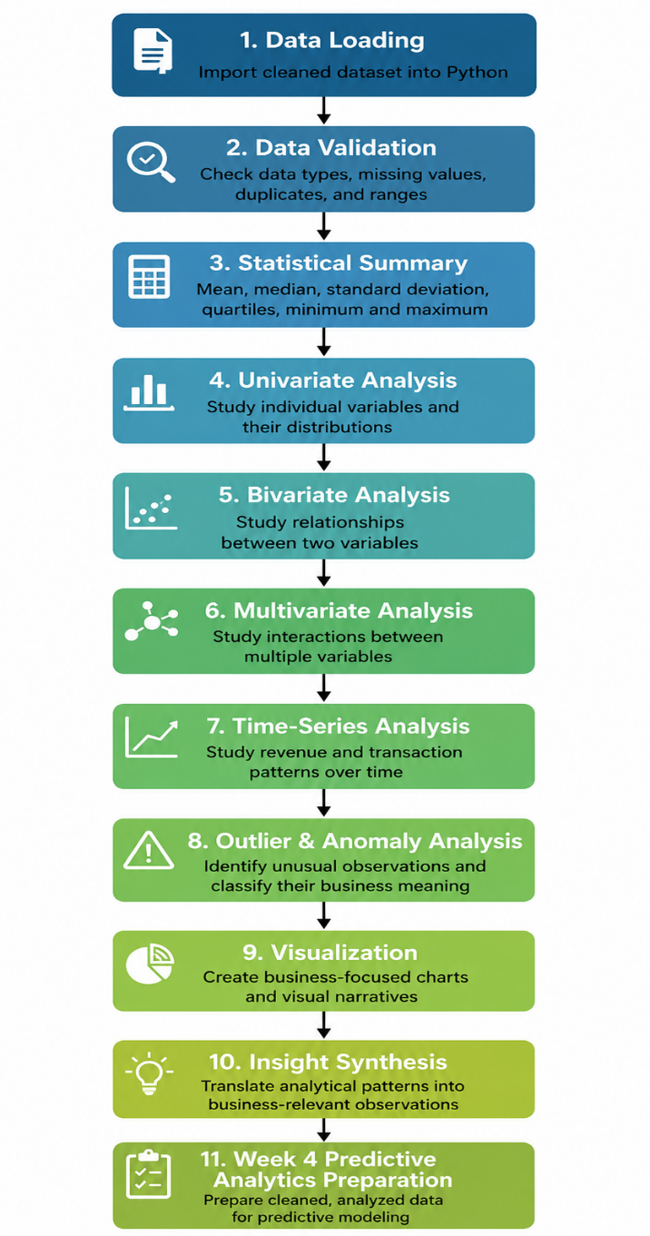
6. STATISTICAL SUMMARY METHODS
Before creating visualizations, a statistical summary will be performed using Pandas and NumPy.
Method | Purpose | Dataset-Specific Reason
df.shape | Determine number of rows and columns | Confirms dataset size and structure
df.info() | Check data types and non-null values | Important because InvoiceDate requires date conversion and CustomerID contains missing values
df.describe() | Calculate numerical statistics | Helps understand Quantity and UnitPrice distributions
df.isnull().sum() | Count missing values | CustomerID missingness affects customer-level analysis
df.duplicated().sum() | Identify duplicate records | Helps distinguish repeated transactions from exact duplicate rows
value_counts() | Frequency of categorical values | Useful for Country, StockCode, and InvoiceNo
groupby() | Aggregate business metrics | Allows revenue and transaction comparisons by country or product
Quantiles/IQR | Detect extreme values | Suitable because retail variables are expected to be skewed
The analysis will calculate:
- Mean
- Median
- Standard deviation
- Minimum
- Maximum
- 25th percentile
- 50th percentile
- 75th percentile
- Interquartile Range

7. UNIVARIATE ANALYSIS
Univariate analysis examines one variable at a time.
7.1 Numerical Variables
The main numerical variables will be:
- Quantity
- UnitPrice
- Revenue
Techniques
- Descriptive statistics
- Histograms
- Box plots
- Percentile analysis
Why this is appropriate
Retail transaction variables are unlikely to follow a perfectly normal distribution. A small number of bulk transactions may contain much larger quantities or values than ordinary purchases.
For example, most transactions may involve relatively small quantities, while wholesale transactions could involve hundreds or thousands of units. A histogram will show the overall distribution, while a box plot will make extreme values easier to identify.
Expected observation
The analysis will determine whether the variables are:
- approximately symmetric,
- right-skewed,
- left-skewed,
- or strongly affected by extreme observations.

8. BIVARIATE ANALYSIS
Bivariate analysis examines relationships between two variables.
8.1 Quantity vs UnitPrice
A scatter plot will be used to investigate whether larger quantities are associated with different unit prices.
Why Appropriate?
Wholesale customers may purchase large quantities at lower unit prices. Therefore, the relationship may provide useful evidence about purchasing behavior.
Expected Analytical Output
A scatter plot and correlation measure showing the direction and strength of the relationship between Quantity and UnitPrice.

8.2 Quantity vs Revenue
A scatter plot and correlation coefficient will be used.
Why Appropriate?
Revenue is calculated using:
Revenue = Quantity × UnitPrice
Therefore, Quantity is directly relevant to revenue generation.
This analysis can help determine whether transaction volume has a strong relationship with monetary value.
Expected Analytical Output
A scatter plot and correlation measure showing how strongly transaction quantity is associated with Revenue and whether high-volume transactions tend to generate greater monetary value.

8.3 UnitPrice vs Revenue
A scatter plot will examine whether higher-priced products contribute proportionally more revenue.
Why Appropriate?
A high UnitPrice does not necessarily mean high total revenue if the product is sold in small quantities. Comparing UnitPrice with Revenue helps distinguish price-driven and volume-driven revenue.
Expected Analytical Output
A scatter plot and correlation measure showing the relationship between UnitPrice and Revenue and helping identify whether revenue is more strongly associated with price or transaction volume.

9. MULTIVARIATE ANALYSIS
Multivariate analysis examines several variables simultaneously.
The analysis will consider:
- Quantity
- UnitPrice
- Revenue
- Country
- Month
- CustomerID
- Product
9.1 Correlation Matrix
A correlation matrix will be created for numerical variables.
Why Appropriate?
It provides a compact overview of relationships among Quantity, UnitPrice, and Revenue.
A heatmap will make stronger and weaker relationships easier to compare visually.
Expected Analytical Output
A correlation matrix and heatmap highlighting the relative strength and direction of relationships among the main numerical variables.

9.2 Country × Month Revenue Analysis
Revenue will be aggregated by both Country and Month.
Why Appropriate?
Revenue may vary across both geographical markets and time periods. Examining these variables together can reveal whether specific countries experience stronger sales during particular periods.
Expected Analytical Output
A country-by-month summary table and heatmap showing geographic and temporal revenue patterns.

9.3 Customer-Level RFM Analysis
RFM stands for:
- Recency: How recently a customer purchased.
- Frequency: How often a customer purchased.
- Monetary: How much a customer spent.
Why Appropriate?
CustomerID is available in the dataset, making customer-level analysis possible for records where CustomerID is present.
RFM analysis provides a foundation for identifying valuable, frequent, and inactive customers and can support later customer segmentation or predictive modeling.
Expected Analytical Output
An RFM summary table and customer-level visualizations showing differences in customer recency, purchase frequency, and monetary value.

10. TIME-SERIES ANALYSIS
The dataset contains InvoiceDate information covering approximately one year. This makes time-based analysis particularly relevant.
10.1 Monthly Revenue
Revenue will be aggregated by month and displayed using a line chart.
Why Appropriate?
A line chart is suitable for continuous time because it clearly communicates increases, decreases, peaks, and possible seasonal patterns.
The analysis will investigate whether revenue increases during particular months, especially during periods leading toward the end of the year.
Expected Analytical Output
A monthly revenue line chart showing changes in sales performance across the analysis period and highlighting potential peaks, declines, or seasonal patterns.

10.2 Weekly and Daily Transactions
Transaction counts will be grouped by week and day.
Why Appropriate?
This can reveal whether purchasing activity is concentrated on particular days or periods.
Expected Analytical Output
Weekly and daily transaction summaries identifying periods with comparatively higher or lower transaction activity.

10.3 Day-of-Week × Hour Analysis
Transaction counts will be compared across day of week and hour.
Visualization
Heatmap
Why Appropriate?
This analysis contains two time-based dimensions and an activity measure. A heatmap can therefore show when transaction activity is concentrated more effectively than separate charts.
Expected Analytical Output
A day-of-week × hour heatmap showing the periods with relatively higher and lower transaction activity.

11. OUTLIER AND ANOMALY DETECTION AND TREATMENT
Outlier handling will extend the logic established during Week 2.
The key principle is:
An unusual value should not automatically be deleted. It should first be investigated to determine whether it represents an error or a legitimate business event.
Anomaly / Issue | Detection Method | Planned Treatment | Reason
Negative Quantity | Filter Quantity < 0 | Separate return transactions from normal sales | Negative quantities may represent genuine product returns
Cancelled Invoices | Check InvoiceNo beginning with C | Exclude from core completed-sales analysis and report cancellation activity separately | Cancelled transactions are different from completed sales
Missing CustomerID | isnull() check | Retain for product/revenue analysis where appropriate but exclude from customer-level RFM analysis | Transactions without customer IDs cannot be reliably attributed to a customer
Extreme Quantity | IQR method and percentile analysis | Flag for review rather than automatically delete | Very large quantities may represent legitimate wholesale purchases
Extreme UnitPrice | IQR and percentile analysis | Flag and investigate | Extreme prices may represent unusual products or data-entry/system issues
Extreme Revenue | IQR analysis on Revenue | Flag separately | High revenue transactions may be legitimate bulk purchases
UnitPrice = 0 | Filter UnitPrice == 0 | Investigate individually before deciding treatment | Could represent free promotional items, adjustments, or data issues
Duplicate Rows | duplicated() | Investigate exact duplicates and remove only where confirmed as accidental | Prevents double counting while avoiding removal of genuine repeated purchases
Outlier Detection Method: IQR
The Interquartile Range method will be used:
IQR = Q3 − Q1
Lower Bound:
Q1 − 1.5 × IQR
Upper Bound:
Q3 + 1.5 × IQR
Values outside these limits will initially be flagged as potential outliers.
However, the IQR method will be treated as a detection mechanism, not an automatic deletion rule.
This distinction is important because a retail dataset can naturally contain high-value wholesale transactions.
Expected Analytical Output
The analysis will produce an outlier and anomaly summary showing the number or proportion of flagged observations, their potential business meaning, and the final treatment decision for each category.

12. VISUALIZATION PLAN
The visualization strategy is designed around business questions rather than creating charts simply for presentation.
Business Question | Variables | Chart Type | Why This Chart Is Appropriate
What does the distribution of Quantity look like? | Quantity | Histogram + Box Plot | Shows distribution, skewness, and extreme values
How is UnitPrice distributed? | UnitPrice | Histogram + Box Plot | Identifies common prices and unusual price values
How is Revenue distributed? | Revenue | Histogram + Box Plot | Helps identify revenue concentration and high-value transactions
Does Quantity relate to Revenue? | Quantity, Revenue | Scatter Plot | Shows relationship and possible volume-driven revenue
Does UnitPrice relate to Revenue? | UnitPrice, Revenue | Scatter Plot | Helps examine whether price contributes to revenue
Which countries generate the most revenue? | Country, Revenue | Horizontal Bar Chart | Easy comparison of categorical groups with readable country labels
Which products sell the most? | StockCode, Quantity | Top-N Bar Chart | Focuses attention on the highest-volume products
Which products generate the most revenue? | Product, Revenue | Top-N Bar Chart | Identifies high-value products
How does revenue change over time? | InvoiceDate, Revenue | Line Chart | Best for showing trends over an ordered time axis
Which days/hours have the highest activity? | Day, Hour, Transactions | Heatmap | Shows two-dimensional activity patterns
How are numerical variables related? | Quantity, UnitPrice, Revenue | Correlation Heatmap | Provides a compact view of multiple relationships
How are customers distributed by value? | Recency, Frequency, Monetary | Scatter Plot / Segmented Chart | Supports customer segmentation
How does revenue vary by country and month? | Country, Month, Revenue | Heatmap | Shows geographic and temporal concentration simultaneously

13. VISUALIZATION DESIGN PRINCIPLES
The visualizations will follow several principles.
13.1 Clear Titles
Each chart will have a descriptive title explaining what is being shown.
Example:
"Monthly Revenue Trend from December 2010 to December 2011"
rather than:
"Revenue Chart"
13.2 Appropriate Axes
Axes will include clear labels and units.
For example:
- Revenue (£)
- Quantity (Units)
- Month
- Number of Transactions
13.3 Avoiding Unnecessary Complexity
Charts will focus on one major analytical message.
For high-cardinality variables such as StockCode, only the Top-N products will normally be displayed.
13.4 Readability
Horizontal bar charts will be preferred where category names are long.
Currency values will be formatted appropriately so that large numbers remain readable.
13.5 Consistency
Matplotlib and Seaborn will be used consistently so that the final report has a professional visual structure.
Plotly may be considered for interactive versions if sufficient time remains within the 30–35 hour work period.

14. Analysis Plan: Anticipated and Actual Outcomes
This section states, for each key question in Section 2, what a plausible outcome would look like and then reports what actually happened when the plan was executed — the two are shown together so the reasoning is checkable.

14.1Data quality
Anticipated: some cancellations and a handful of missing customer IDs, likely under 10% combined.
Actual outcome: missingness was larger than a typical guess — 135,080 rows (24.9%) lack a CustomerID, though cancellations (1.71%) and invalid prices (0.46%) were smaller than they might first appear. After removing all data-quality issues, 392,692 of 541,909 rows (72.5%) remained usable.

14.2 Distribution shape
Anticipated: Quantity and UnitPrice are unlikely to be normally distributed in a retail dataset with wholesale buyers.
Actual outcome: confirmed — both variables are heavily right-skewed (median Quantity = 3 units, median UnitPrice = £2.08), with the mean pulled well above the median by a small number of large orders.

14.3 Outliers
Anticipated: outliers exist but should be flagged, not deleted, given the wholesale customer base.
Actual outcome: IQR flagged 6.52% of rows as Quantity outliers, 8.69% as UnitPrice outliers, and 7.95% as Revenue outliers — in the expected single-digit-percent range, supporting a flag-and-retain rather than delete strategy.

14.4 Variable relationships
Anticipated: Quantity and Revenue should correlate more strongly than UnitPrice and Revenue, since bulk orders likely matter more than item price.
Actual outcome: confirmed by the correlation heatmap — Quantity shows a clearly stronger relationship with Revenue than UnitPrice does, indicating order volume is the primary revenue driver.

14.5 Time patterns
Anticipated: a seasonal, pre-Christmas revenue increase given the “all-occasion gift” product line.
Actual outcome: confirmed — revenue rose from £446K (Feb 2011) to a peak of £1.156M (Nov 2011). The day/hour heatmap also showed a business-hours (10:00–15:00), weekday-only ordering pattern with almost no Saturday activity, consistent with a wholesale-leaning customer base rather than typical evening/weekend consumer shopping.

14.6 Segment concentration
Anticipated: the UK likely dominates, since the retailer is UK-registered.
Actual outcome: confirmed and more extreme than a cautious guess — the UK alone accounts for 81.97% of total revenue (£7.29M of £8.89M), with the Netherlands, EIRE, Germany, and France a distant second tier. A parallel RFM pass showed the same concentration pattern at the customer level: median customer spend was £668.57 but the maximum was £280,206.02.
Example chart supporting 14.4 and 14.5:
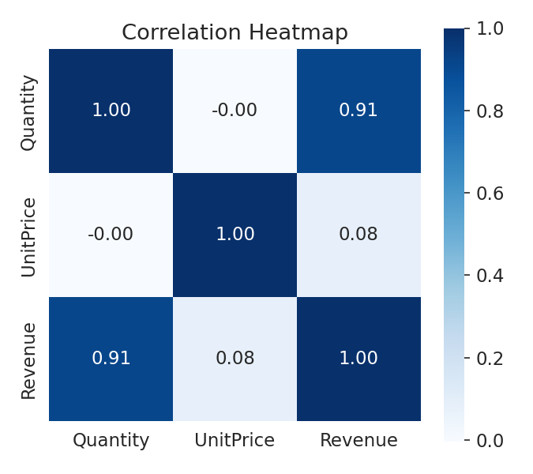
Figure 1. Correlation heatmap of Quantity, Unit Price, and Revenue.

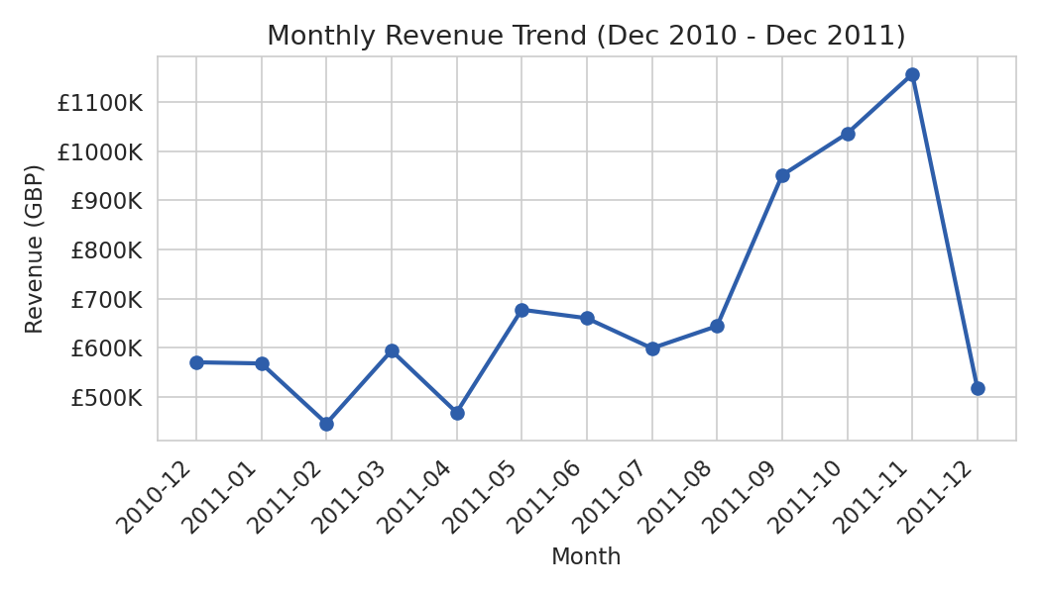
Figure 2. Monthly revenue trend, Dec 2010–Dec 2011.

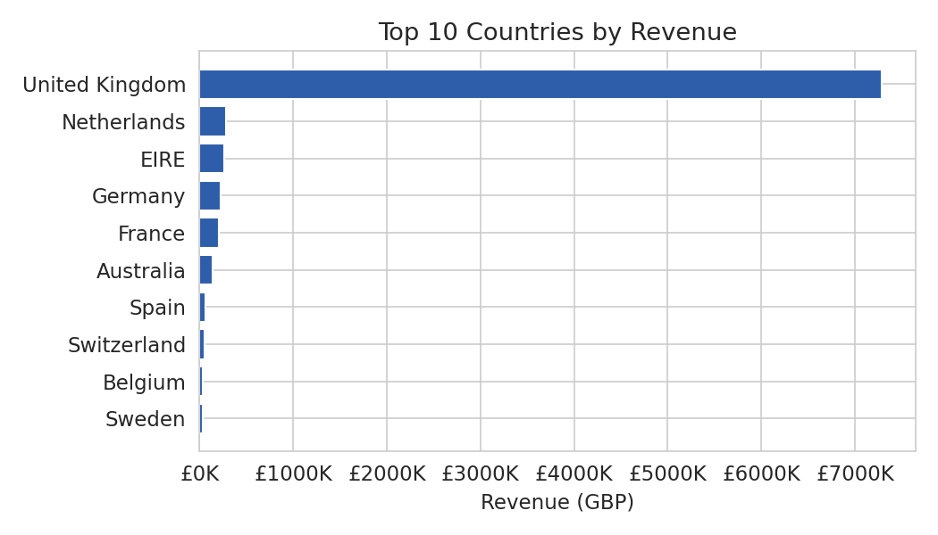
Figure 3. Top 10 countries by revenue — evidence for the concentration question.

15. PYTHON TOOLS AND METHODOLOGY
The following Python libraries will be used:
Library | Purpose
Pandas | Data loading, cleaning validation, grouping, aggregation, and time-series preparation
NumPy | Numerical calculations and statistical operations
Matplotlib | Core charts and customized visualizations
Seaborn | Heatmaps, statistical plots, and correlation visualization
Plotly | Optional interactive charts
Jupyter Notebook / VS Code | Analysis environment and documentation
Planned EDA Sequence
Step 1: Load Dataset
The dataset will be imported using Pandas.
Step 2: Validate Structure
The following will be checked:
- Number of records
- Number of variables
- Data types
- Missing values
- Duplicate records
Step 3: Prepare Analytical Variables
InvoiceDate will be converted into datetime format.
Revenue will be calculated as:
Revenue = Quantity × UnitPrice
Additional time variables may include:
- Year
- Month
- Week
- Day
- Hour
- Day of Week
Step 4: Perform Statistical Analysis
Descriptive statistics and frequency distributions will be generated.
Step 5: Perform EDA
Univariate, bivariate, multivariate, and time-series techniques will be applied.
Step 6: Detect Anomalies
IQR, logical rules, and business-context checks will be combined.
Step 7: Create Visualizations
Charts will be selected according to the business questions defined earlier.
Step 8: Document Insights
Only observations supported by executed analysis will be reported as actual findings.

16. DATASET-SPECIFIC EXAMPLES TO BE INVESTIGATED
To make the EDA more meaningful, the analysis will investigate examples directly related to this dataset.
Example 1: Bulk Purchases
A transaction with an unusually high Quantity will be investigated to determine whether it represents a legitimate wholesale purchase.
Example 2: Returns
Transactions with negative Quantity will be separated and examined as potential product returns rather than automatically treating them as errors.
Example 3: Cancelled Orders
Invoices beginning with "C" will be analyzed separately to understand cancellation activity.
Example 4: Missing Customer Information
Transactions without CustomerID will still be useful for product and revenue analysis, but they cannot reliably contribute to customer-level RFM analysis.
Example 5: Zero UnitPrice
Rows where UnitPrice is zero will be investigated to determine whether they represent free items, promotional activity, adjustments, or possible data-quality problems.
Example 6: Seasonal Revenue
Monthly revenue will be examined to determine whether sales activity changes during different parts of the year.
These examples ensure that the EDA remains connected to real characteristics of the Online Retail dataset rather than being a generic list of statistical techniques.

17. EXPECTED DELIVERABLES
The following outputs are the expected deliverables of the Week 3 EDA and Visualization stage. They represent the planned outputs that will be generated through Python-based analysis of the UCI Online Retail Dataset. The section does not claim that these outputs have already been calculated or observed.
Expected Deliverable | Purpose / Expected Output
Dataset validation summary | Summary of dataset structure, data types, missing values, duplicates, and valid analytical records
Descriptive statistics table | Mean, median, standard deviation, quartiles, minimum, and maximum for key numerical variables
Quantity distribution chart | Histogram and box plot showing the distribution and potential extreme values of Quantity
UnitPrice distribution chart | Histogram and box plot showing price distribution and unusual price observations
Revenue distribution chart | Visualization of transaction revenue distribution and potential high-value transactions
Quantity vs Revenue scatter plot | Visual assessment of the relationship between transaction volume and revenue
UnitPrice vs Revenue scatter plot | Examination of the relationship between unit price and transaction revenue
Correlation matrix and heatmap | Summary of relationships among Quantity, UnitPrice, and Revenue
Revenue by Country chart | Comparison of revenue contribution across countries
Top products by Quantity | Identification of products with the highest sales volume
Top products by Revenue | Identification of products contributing the greatest monetary value
Monthly revenue trend | Line chart showing changes in revenue across the analysis period
Day-of-week × Hour heatmap | Identification of periods with higher or lower transaction activity
Outlier and anomaly treatment table | Documentation of detected unusual observations and their planned analytical treatment
RFM customer summary | Customer-level Recency, Frequency, and Monetary analysis for customers with available CustomerID
Business interpretation of findings | Explanation of the analytical patterns discovered and their potential business meaning

Result Status
All numerical values, statistical measurements, chart outputs, outlier counts, correlations, rankings, and analytical findings will be populated after the Python analysis is executed. The expected deliverables above therefore describe the intended outputs rather than presenting unverified results.
This approach ensures that the Week 3 report distinguishes clearly between the EDA methodology and expected outputs and the actual findings produced from the dataset.

18. QUALITY AND VALIDATION CHECKS
Before finalizing the EDA, the following checks will be performed:
Data Validation
- Confirm row and column counts.
- Confirm correct data types.
- Check missing values.
- Check duplicate records.
- Confirm Revenue calculation.
Analytical Validation
- Compare mean and median for skewed variables.
- Check whether extreme values are genuine business observations.
- Ensure cancelled transactions are not incorrectly counted as completed sales.
- Ensure returns are not mixed with normal sales.
- Confirm that CustomerID-based analysis uses only identifiable customers.
Visualization Validation
- Check chart titles and axis labels.
- Check whether units are clearly displayed.
- Avoid misleading scales.
- Ensure categories are readable.
- Ensure each visualization answers a specific business question.

19. EXPECTED OUTCOMES
The EDA is expected to provide a clearer understanding of:
- The typical transaction size and value.
- The distribution and skewness of Quantity, UnitPrice, and Revenue.
- Potential relationships between quantity, price, and revenue.
- Major revenue-contributing countries.
- High-performing products.
- Changes in revenue over time.
- Customer purchasing behavior.
- Statistical outliers and their business meaning.
- Data patterns that could influence future predictive models.
- Variables that should receive greater attention in later stages of the project.
These are expected analytical outcomes, not claims that the results have already been observed.

20. LINK TO FUTURE PREDICTIVE ANALYTICS
The EDA stage will provide the foundation for later predictive analytics.
For example:
- Revenue distributions can guide transformation or scaling decisions.
- Outlier analysis can prevent extreme observations from distorting models.
- Customer RFM analysis can support customer segmentation.
- Time-series patterns can help identify useful temporal features.
- Country and product analysis can identify relevant categorical features.
- Correlation analysis can highlight relationships between numerical variables.
Therefore, EDA is not an isolated reporting activity. It acts as a bridge between data preparation and predictive modeling.

21. TIMELINE
The task is planned within the expected 30–35 hour workload.
Day | Activity | Planned Output | Estimated Time
Day 1 | Load dataset, validate structure, inspect data types, missing values and duplicates | Dataset validation summary | 4–5 hours
Day 2 | Perform descriptive statistics and univariate analysis | Statistical tables, histograms, box plots | 5 hours
Day 3 | Detect and investigate outliers, cancellations, negative quantities, missing IDs and zero prices | Anomaly/outlier treatment log | 5 hours
Day 4 | Perform bivariate analysis | Scatter plots and relationship summaries | 4–5 hours
Day 5 | Perform multivariate and categorical analysis | Correlation heatmap, country/product analysis | 5 hours
Day 6 | Perform time-series analysis and RFM groundwork | Monthly trend, day/hour heatmap, RFM table | 5 hours
Day 7 | Finalize visualizations, interpret results, prepare report and review | Completed Week 3 report and analysis outputs | 4–5 hours
Total estimated effort: approximately 32–35 hours.

21. CONCLUSION
Week 3 develops a structured Exploratory Data Analysis and visualization strategy for the UCI Online Retail Dataset. The plan directly continues the dataset profiling and cleaning logic established during Week 2.
The analysis will examine the dataset at four major levels: univariate, bivariate, multivariate, and time-series analysis. Each technique has been selected according to the characteristics of the Online Retail dataset and the business questions that the project aims to answer.
Special attention will be given to negative quantities, cancelled invoices, missing CustomerIDs, extreme values, zero UnitPrice values, and duplicate records. Rather than automatically deleting unusual observations, the strategy considers whether each observation represents a genuine business event or a data-quality problem.
The visualization strategy also connects each business question to an appropriate chart type, including histograms, box plots, scatter plots, bar charts, line charts, and heatmaps.
The seven-day execution plan provides a practical roadmap for completing the analysis within the expected 30–35 hour workload.
Most importantly, the report clearly distinguishes planned/expected deliverables from actual analytical findings. Numerical results and final observations will only be reported after the dataset has been executed and analyzed in Python. This ensures that the Week 3 submission remains evidence-based, reproducible, and suitable as a foundation for the predictive analytics stages that follow.

